**Project Design Phase-I**

**Solution Architecture**

|  |  |
| --- | --- |
| Date | 19 Oct 2023 |
| Project Name | Food Tracking System |

**Solution Architecture:**

Solution architecture is a complex process – with many sub-processes – that bridges the gap between business problems and technology solutions. Its goals are to:

* Find the best tech solution to solve existing business problems.
* Describe the structure, characteristics, behaviour, and other aspects of the software to project stakeholders.
* Define features, development phases, and solution requirements.
* Provide specifications according to which the solution is defined, managed, and delivered.

**Solution Architecture Diagram for Blockchain-Powered Library Management**

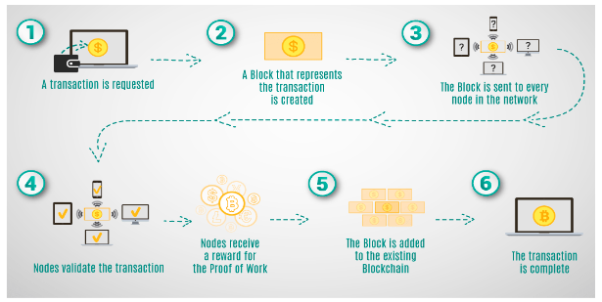

**Key Features:**

1. **Blockchain Integration:** Data recorded on the blockchain is immutable and cannot be altered, ensuring the integrity of the food supply chain data.The system leverages a decentralized blockchain network, reducing the risk of a single point of failure and enhancing security. Stakeholders can trust the data on the blockchain without relying on intermediaries, promoting transparency.

2. **Smart Contracts:** Smart contracts automate various supply chain processes, such as payment settlements, quality control checks, and compliance verification.Smart contracts execute actions based on predefined conditions, allowing for automatic responses to events in the supply chain.The use of smart contracts provides real-time visibility into the status and location of food products.

3. **User-Friendly Interface:** The user interface is designed for ease of use, allowing all stakeholders to navigate the system with minimal training.The interface is accessible from desktop computers, tablets, and smartphones, providing flexibility for users.Complex supply chain data is presented through charts, graphs, and dashboards, making it easier to understand and analyze.

4. **Permissioned Access Control:** Users are granted access based on their roles within the supply chain, ensuring they only see relevant information and perform appropriate actions.Sensitive information, such as proprietary data or financial records, is protected from unauthorized access.The system maintains detailed audit trails to track user interactions, providing transparency and accountability.

5. **Transparent Cataloging:** Each food product is assigned a unique digital identity, such as a product code or serial number, simplifying identification and tracking.Detailed product information, including origin, production, processing, and transportation details, is cataloged, offering a comprehensive view of each product's journey.The system records a transparent history of each food product's movement and changes, allowing users to view its entire lifecycle.

6. **Data Encryption:** All data stored on the blockchain is encrypted, ensuring protection against unauthorized access and maintaining data confidentiality.Data exchanged between supply chain participants and the system is transmitted using secure encryption protocols, safeguarding information during transit.The encryption guarantees that data remains unaltered and authentic, preserving the reliability of the information stored on the blockchain.

**Development Phases:**

1. **Project Planning and Research:** Comprehensive research and requirements gathering to understand the needs and challenges of the food supply chain.Creation of a detailed project plan outlining objectives, timelines, and resource allocation.

2. **System Design:** Architectural design of the system, including database structures, data flow, and integration points.Defining the user experience and workflow for all stakeholders within the supply chain.

3. **Blockchain Integration:** With the design in place, the project moves to the development of the blockchain infrastructure and smart contracts. This is a core technical phase that establishes the secure and decentralized foundation of the system.

4. **User Interface Development:** The user interface development phase focuses on designing and building the user-friendly interface that librarians and patrons will interact with. It's crucial to ensure that the system is accessible and easy to navigate.

5. **Access Control and Security:** This phase involves implementing permissioned access control and security measures to protect data and ensure that only authorized individuals can interact with the system.

6. **Cataloging and Indexing:** Building the decentralized cataloging and indexing system is the heart of the project's functionality, enabling transparent and efficient resource management.

7. **Deployment and Monitoring:** The final phase encompasses the staged rollout of the system and continuous monitoring for performance, security, and user feedback. Monitoring and maintenance remain ongoing tasks to ensure the system's long-term success.

**Solution requirements:**

1. **Blockchain Infrastructure:** The project necessitates a strong blockchain foundation, potentially utilizing platforms like Ethereum, and associated blockchain development tools.

2. **Smart Contract Development:** Skilled developers proficient in creating and deploying smart contracts are vital to automate and ensure the reliability of key processes.

3. **User Interface Designers:** Talented user interface designers and developers are needed to create an appealing and intuitive interface that enhances user experience and adoption.

4. **Access Control Implementation**: Security experts are required to implement role-based access control, ensuring the system's security and privacy.

5. **Data Encryption:** Encryption technologies and experts are necessary to safeguard sensitive data and protect it from unauthorized access.

6. **Server Infrastructure:** Reliable servers and cloud services are needed for hosting the system and ensuring uninterrupted access.

7. **Monitoring and Maintenance:** Resources for continuous monitoring and updates are required to keep the system secure, performant, and aligned with evolving needs. This includes a team responsible for system upkeep and enhancements.